REFLECTIVE ADDRESS MARKERS
Name: _____________________________________________________________
Address: ___________________________________________________________
Phone: _______________________________ Post: _____________________
Order rec’vd by: Phone Mail Door to Door Walk In
Payment Rec’vd: Yes or No Date: __________

___________________________________________________________________

South Wheatland Fire Protection District
Received from: ______________________________________________________
Ten and 00/100 ($10) in payment for Reflective Marker for: _________________
__________________________________________________________________
Date: ___________________________ Rec’vd by: _____________________

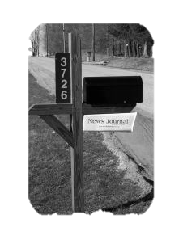
IF WE CAN’T FIND
YOU WE CAN’T
HELP YOU
ONLY $10.00

